Write a query to find the addresses (location_id, street_address, city, state_province, country_name) of all the departments.

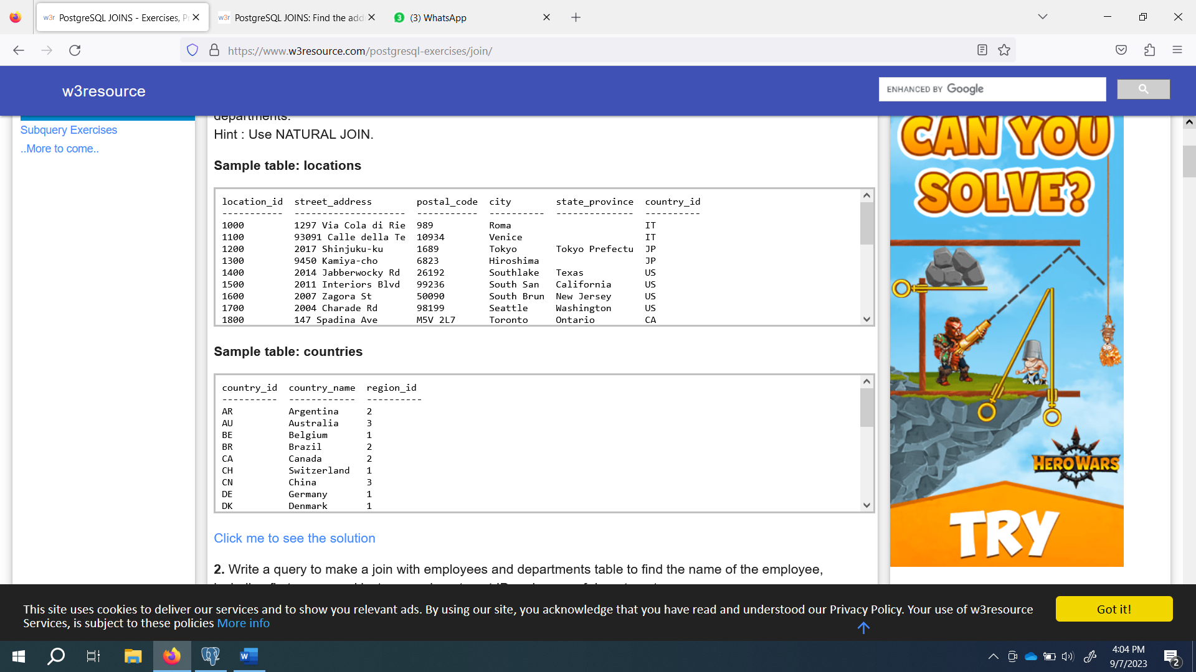

Write a query to make a join with employees and departments table to find the name of the employee, including first_name and last name, department ID and name of departments.

